

**How to charge VistaZ battery?**

v1.0

**Contents**

1. Pre-Requisite 3

2. Battery charging limit for Air travel 4

3. How to charge the 18650 battery without defined charging current 4

4. Li-ion Battery Mode Selection 5

5. Setting the charging current to desired level 6

6. Battery Charging Status 7

### Pre-Requisite

* 1. [Nitecore UM4](https://charger.nitecore.com/product/um4) battery charger – 1 qty
  2. [A Male to Micro B cable](https://www.amazon.com/Cable-Type-Micro-Black-Color/dp/B00860R2FM) – 1 qty
  3. Howell 2500mAH/3000mAh 18650 batteries – 1 qty
  4. [USB wall adapter](https://www.amazon.com/Anker-Charger-Durable-Compact-Included/dp/B099F558S1/?th=1) – 1 qty

### Battery charging limit for Air travel

18650 batteries should not be fully charged but can be 70% only during the Air travel as per the Air shipment guidelines. So when batteries needs to ship through Air to another location, can be charged till 3.85v/4.0v(3.85v for 2500mAh batteries and 4.0 for 3000mAh batteries. Else batteries can be fully(4.2v) charged for local uses/deployment.

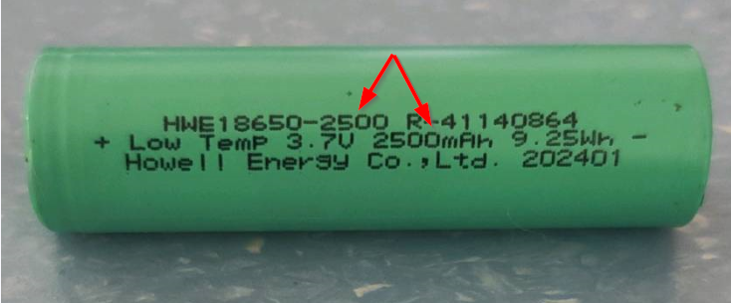

### How to charge the 18650 battery without defined charging current

* + Plug the Micro USB cable into Nitecore UM4 charger, without battery it will look like as below

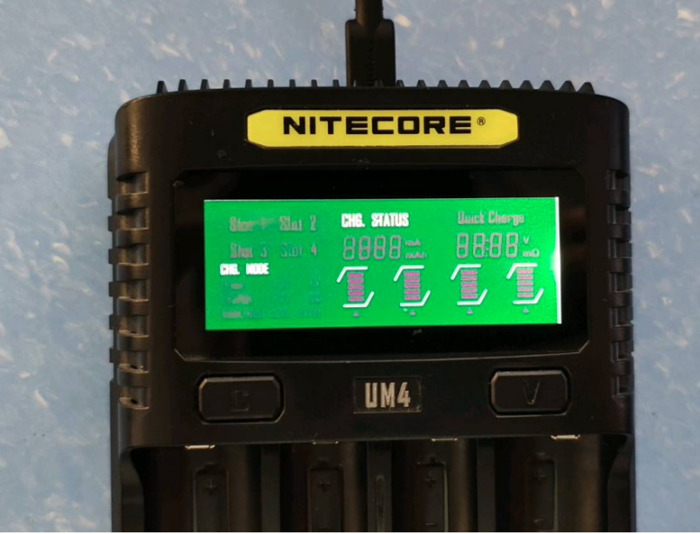

* + If you want to skip the charging current value settings, by inserting the 18650 battery into slot, it will be charge by default charging settings.
  + Below image showing charging time in right and charging current in mA in middle
  + Make sure to turn off charger when battery shows **3.85v/4.0v**(Based on #2 topic)

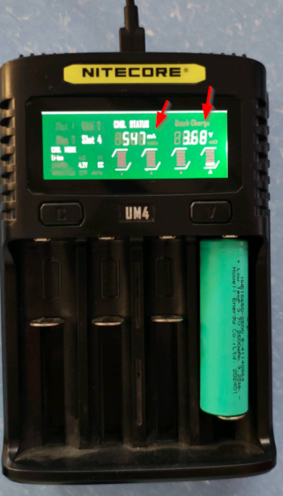

### Li-ion Battery Mode Selection

* + On Nitecore UM4 battery charger, you have two tactile button next to written “UM4”
  + On the Left with engraved letter “C” and on the right with engraved letter “V”
  + Press “C” and hold for 2 sec to enter the charging setting mode
  + Press “C” again to enter battery type selection
  + Current battery type will start flashing
  + By pressing “V”, change to **Li-ion, 4.2v**
  + Once the values are finalized, long press “C” button to save the value and exit from battery type selection mode

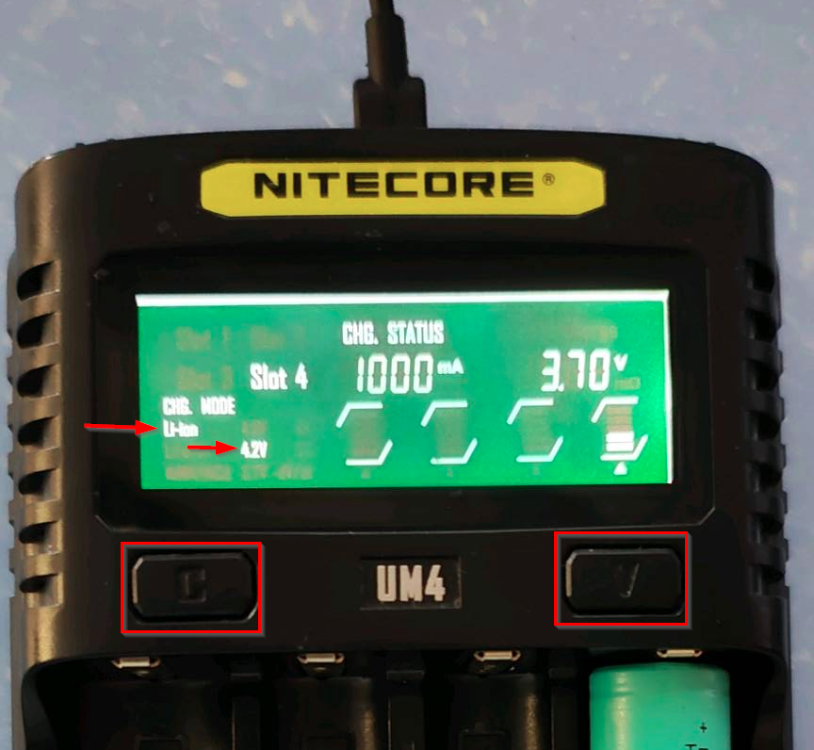

### Setting the charging current to desired level

* + Press “C” button and hold for 3 sec to enter the charging setting mode
  + Charging current value will start flashing
  + By pressing “V”, numeric value can be increased/decreased
  + Once the values are finalized, long press “C” button to save the value and exit from charging setting mode

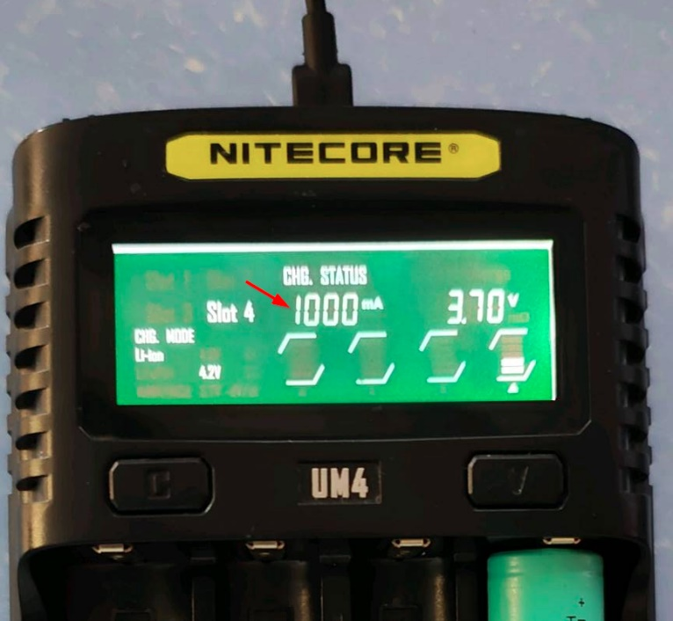

### Battery Charging Status

* + When battery is charging, screen information will be updating based on current status
    - Charging time(HH:MM)
    - Battery present voltage
    - mAh gained/charged
    - Charging current
    - Battery health
    - Battery internal resistance
    - Battery mounted in slot number
    - Charging mode
  + By pressing “V” charging status display can be checked for specific screen
  + Backlight of the screen will be dimmed after certain period of time

